Chapter 10, Solution 78.

Determine v_{o}(t) in the op amp circuit in Fig. 10.121 below.

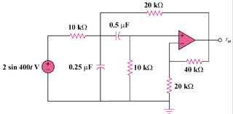

Figure 10.121
For Prob. 10.78.

Solution
+

+

40 k

-j10 k

V₂

V₁

20 k

20 k

-j5 k

10 k

20 V

10 k

V_{o}
Consider the circuit as shown below.
At node 1,
(1)
At node 2,
(2)
But
(3)
From (2) and (3),
(4)
Substituting (3) and (4) into (1) gives
Therefore,
3.945sin(400t–9.46) V

